ZH,
REPORT OF JIV ON 6” ALINSO 2L – FLOWLINE @ OMOKU, ONELGA, RIVERS STATE.

ATTENDANCE:
NELSON IKEDIASHI NOSDRA
JAMES ORDU RVSMENV
IHEDIKE OLIVER NAOC (HSE)
OZZRO O.I NAOC
AMUA FELIX COMMUNITY REP.

SPILL SITE DETAILS
INCIDENT NO 2019/LAR/045
DATE OF INCIDENT 11-04-2019
DATE OF JIV 12-04-2019
QNTY OF OIL SPILLED 43.6BBLS
QNTY RECOVERED NIL
AREA IMPACTED 3298m²
SPILL POINT COORDINATES N05⁰ 23’01.5”, E006⁰ 39’ 09.7”

OBSERVATIONS
- A 120mm hacksaw cut @ 4 – 7 o’clock position was observed on the flowline.
- It was observed to be done by an unknown person.
- Repair of affected section was carried out immediately.

RECOMMENDATION
- Naoc should increase surveillance on the facility.

PICTORAL DOCUMENTATION:
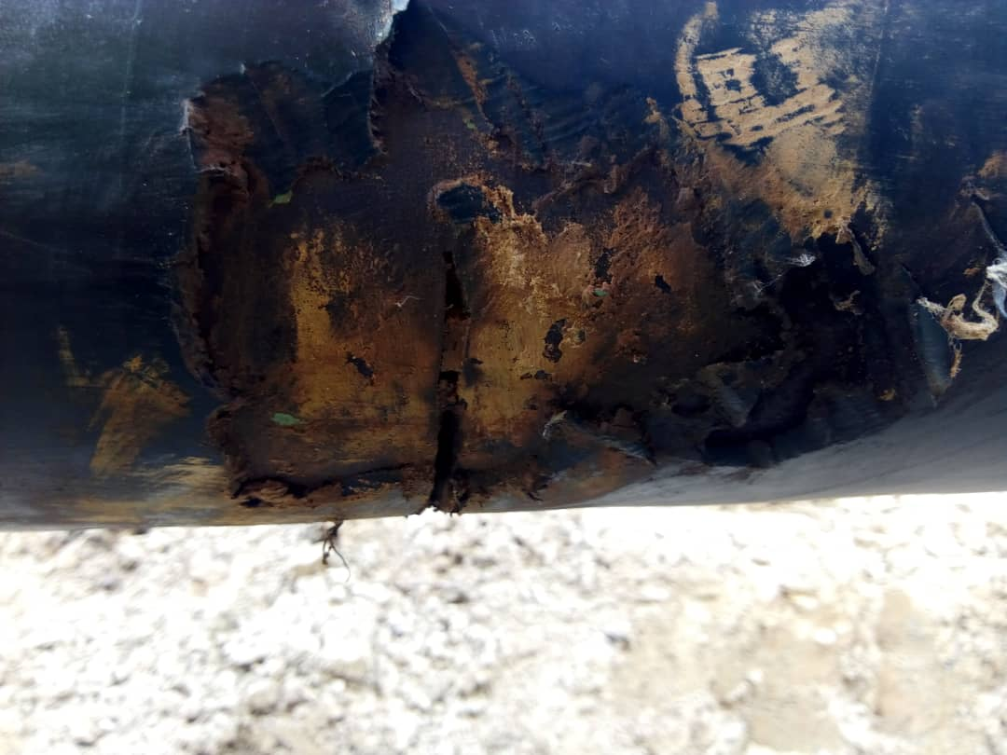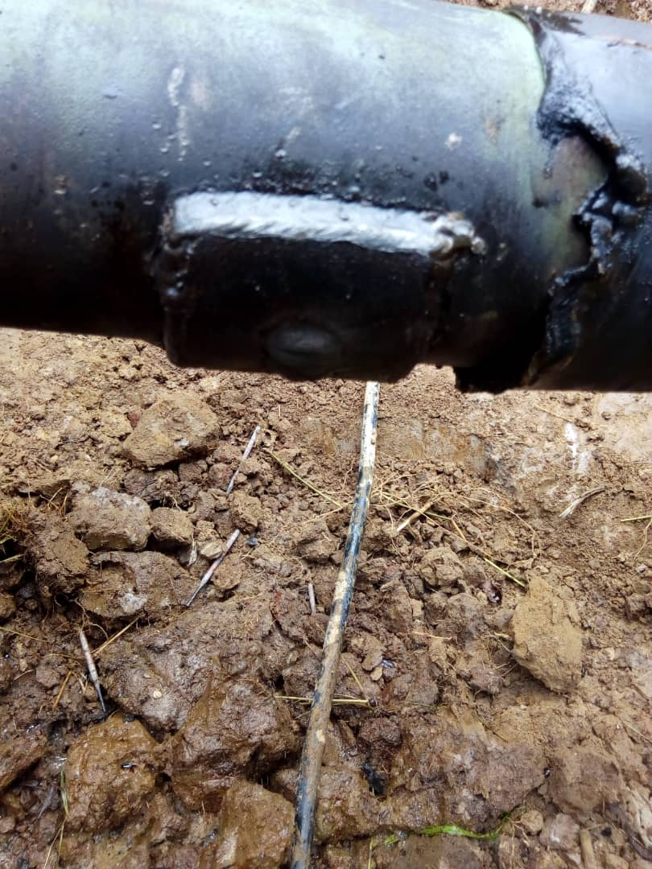
SPILL SITE. PIPE REPAIRED

IKEDIASHI, N.C
ES I

